**INTRODUCTION TO DATA MANAGEMENT**

**PROJECT REPORT**

(Project Semester January-April 2025)

**ELECTRIC VEHICLE POPULATION DASHBOARD**

Submitted by

Name: Saatvik Cheruku

Reg. No.: 12308545

B-Tech CSE – K23GS

Course Code: INT217

Under the Guidance of

**Baljinder Kaur Mam**

**UID: 27952**

**Assistant Professor**

**Discipline of CSE/IT**

**Lovely School of Computer Science and Engineering**

**Lovely Professional University, Phagwara**

**CERTIFICATE**

This is to certify that Saatvik Cheruku bearing Registration no.12308545 has completed INT217 project titled, **“ELECTRIC VEHICLE POPULATION DASHBOARD**

**”** under my guidance and supervision. To the best of my knowledge, the present work is the result of his/her original development, effort and study.

**Baljinder Kaur Mam**

**Assistant Professor**

**School of Computer Science and Engineering**

Lovely Professional University

Phagwara, Punjab.

Date: April 12, 2025

**DECLARATION**

I, Saatvik Cheruku, student of B-Tech CSE (Program name) under CSE/IT Discipline at, Lovely Professional University, Punjab, hereby declare that all the information furnished in this project report is based on my own intensive work and is genuine.

Date: April 12, 2025 Signature

Registration No.12308545 Saatvik Cheruku

**Acknowledgement**

I would like to express my sincere gratitude to **Baljinder Kaur** mam for their invaluable guidance and support throughout this project. Their insights and expertise have greatly contributed to the successful completion of this research.

I extend my appreciation for providing essential resources and encouragement during this study. Their constructive feedback and suggestions have been instrumental in refining our analysis.

I would also like to thank him for their continuous motivation and assistance in various aspects of this project. Lastly, I am grateful for their unwavering support and belief in my abilities.

This project would not have been possible without the collective efforts of all those who contributed in different ways.

**Thank you, mam.**

**Table of Contents**

1. Introduction

2. Source of Dataset

3. Dataset Preprocessing

4. Analysis on Dataset

i. Top EV Makes in Washington (Clustered Bar Chart)  
ii. EV Adoption by Model Year (Line Chart With Markers)  
iii. EV Count by County (Column Chart)  
iv. Electric Range vs Base MSRP (Clustered Column Chart)  
v. EV Distribution by Utility Providers (Multi-ring Donut Chart)  
vi. Interactive Filters: County, Model Year, Make, Vehicle Type (Slicers)  
vii. Key Performance Indicators – Total EVs, Top Make, Avg. MSRP, Avg. Range (KPI Cards)

5. Conclusion

6. Future Scope

7. References

1. **INTRODUCTION**

The rapid adoption of electric vehicles (EVs) has become a defining trend in the pursuit of sustainable transportation. This project, titled "Electric Vehicle Adoption Dashboard – Washington State", aims to analyze the current landscape of EV adoption across various counties in Washington. The dashboard provides a comprehensive view of key metrics such as vehicle makes, model years, MSRP, electric range, and geographic distribution. By leveraging Excel’s analytical and visualization capabilities, this project not only helps identify adoption patterns but also offers insights into the factors driving the popularity of EVs. The interactive nature of the dashboard enables users to filter data by county, manufacturer, model year, and EV type, allowing for targeted analysis. This project is a step toward understanding how electric mobility is shaping regional transportation dynamics and supporting data-driven decisions for future infrastructure and policy development.

1. **SOURCE OF DATASET**

The dataset used in this project was obtained from the official **Data.gov** platform, specifically from the [Electric Vehicle Population Data](https://catalog.data.gov/dataset/electric-vehicle-population-data) published by the Washington State Department of Licensing (DOL). This dataset provides detailed information on registered electric vehicles across Washington State, including vehicle make and model, model year, electric vehicle type (Battery Electric Vehicle or Plug-in Hybrid Electric Vehicle), MSRP, electric range, and county of registration. The data was downloaded in CSV format and served as a reliable and comprehensive source for conducting analysis and building the Excel dashboard.

1. **DATA PREPROCESSING**

Before performing any analysis or visualization, the dataset was carefully preprocessed to ensure accuracy and consistency. The preprocessing steps included the following:

1. **Data Cleaning:**
   * Removed rows with missing or null values in critical columns such as Make, Electric Range, and Base MSRP.
   * Filtered out entries where the Base MSRP was not available or improperly recorded.
2. **Column Formatting:**
   * Converted numerical columns like Electric Range and Base MSRP to appropriate number formats.
   * Standardized text entries for consistency (e.g., trimming whitespace and correcting inconsistent naming conventions in the Make column).
3. **Derived Columns:**
   * Added a new column named MSRP Available to indicate whether a base MSRP value was present for each entry.
   * Created custom segments for analyzing EV distribution by County, Model Year, and Vehicle Type.
4. **Filtering for Dashboard:**
   * Only entries with valid MSRP values were used for calculating average MSRP and plotting Electric Range vs MSRP.
   * Filtered out any outdated or irrelevant data entries that could skew the analysis.

These preprocessing steps ensured that the data used for the dashboard was accurate, meaningful, and ready for effective visualization and insight generation.

1. **ANALYSIS ON DATASET**

Each objective is supported by PivotTables, slicers, and well-formatted charts for easy interpretation.

**Objective 1: Top EV Makes**

**i. General Description:**  
This objective identifies and compares the most common electric vehicle manufacturers in Washington State using a clustered bar chart.

**ii. Specific Requirements:**  
A PivotTable was created with “Make” in rows and the count of VINs in values. The data was sorted in descending order to highlight the top makes.

**iii. Analysis Result:**  
Tesla was observed to be the leading electric vehicle make, followed by Nissan, Chevrolet, and Ford.

**iv. Visualization:**  
A clustered bar chart was used to clearly compare the top EV makes by vehicle count. The chart was enhanced with data labels and slicers for interactivity.

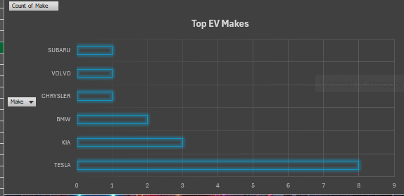

**Objective 2: EVs by Model Year**

**i. General Description:**  
This objective tracks the adoption of electric vehicles over time by analyzing the number of EVs registered each model year.

**ii. Specific Requirements:**  
A PivotTable was built with “Model Year” in rows and count of VINs as values. The data was sorted in chronological order to show trends.

**iii. Analysis Result:**  
The number of EVs steadily increased, with a noticeable peak in recent years, especially in model year 2023.

**iv. Visualization:**  
A line chart was used to visualize the growth in EV adoption over the years. Slicers for County, Make, and EV Type enabled detailed analysis.

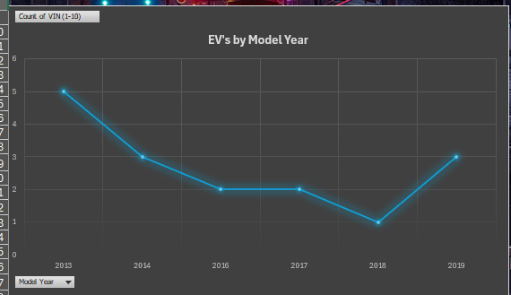

**Objective 3: Electric Range vs Base MSRP**

**i. General Description:**  
This objective analyzes the relationship between an electric vehicle’s driving range and its manufacturer’s suggested retail price (MSRP).

**ii. Specific Requirements:**  
The dataset was cleaned to remove missing or zero values for MSRP and Electric Range. The resulting data was used in a scatter plot with MSRP on the x-axis and range on the y-axis.

**iii. Analysis Result:**  
The chart indicates that while some expensive vehicles offer longer ranges, many mid-priced vehicles also offer competitive ranges, showing market diversity.

**iv. Visualization:**  
A scatter plot was used to showcase the relationship between range and cost. Data points were formatted for readability and slicers were applied to explore specific segments.

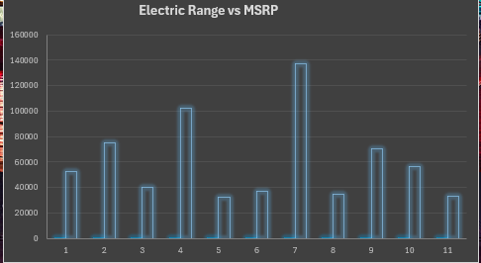

**Objective 4: EV Count by County**

**i. General Description:**  
This objective explores how electric vehicle adoption varies across different counties in Washington State.

**ii. Specific Requirements:**  
A PivotTable was created with “County” as rows and count of VINs as values. The table was sorted by descending count to identify high-adoption areas.

**iii. Analysis Result:**  
King County emerged as the county with the highest number of EVs, followed by Snohomish and Pierce counties.

**iv. Visualization:**  
A vertical bar chart was used to compare EV counts by county. A County slicer was provided for focused regional analysis.

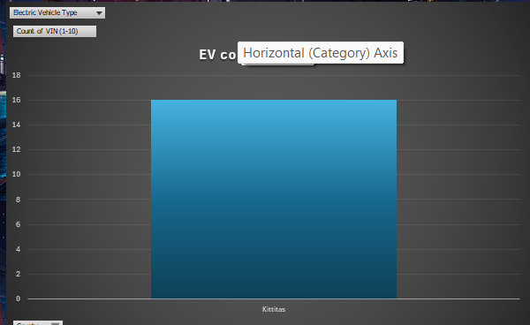

**Objective 5: Electric Utility Providers**

**i. General Description:**  
This objective shows the distribution of electric vehicles by utility providers to understand infrastructure usage and reach.

**ii. Specific Requirements:**  
A PivotTable was created using “Electric Utility” as rows and count of VINs as values.

**iii. Analysis Result:**  
Several utilities were found to serve large numbers of EVs, with providers like Puget Sound Energy serving the most.

**iv. Visualization:**  
A donut chart was used to visualize the share of EVs supported by each electric utility. Slicers allowed filtering by model year, make, and county.

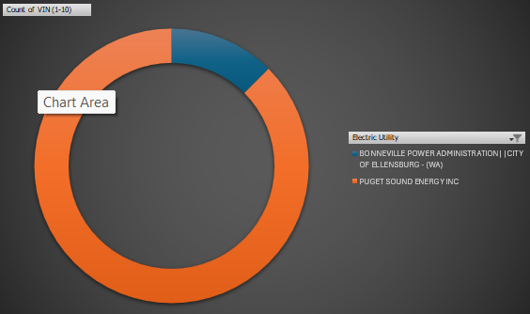

1. **CONCLUSION**

The Electric Vehicle Adoption Dashboard for Washington State provides valuable insights into the growing EV market using interactive visualizations and well-structured data analysis. By leveraging PivotTables, slicers, and various chart types, this project highlights key trends such as the most popular EV makes, increasing adoption over model years, regional distribution by county, pricing vs range comparisons, and utility service coverage.

The use of KPIs further enhances the dashboard’s effectiveness by presenting key metrics like total EV count, top make, average MSRP, and average electric range in a concise and accessible format. Overall, the dashboard serves as a powerful tool for understanding EV adoption patterns and can support informed decision-making for consumers, manufacturers, and policymakers.

1. **FUTURE SCOPE**

As the adoption of electric vehicles (EVs) continues to grow rapidly, the scope of this dashboard can be expanded in several impactful ways:

1. **Real-Time Data Integration**  
   Incorporating APIs to fetch real-time data about EV registrations, charging stations, or pricing updates can transform the static dashboard into a dynamic tool, offering up-to-date insights for decision-making.
2. **Charging Infrastructure Analysis**  
   A dedicated section could be added to analyze the distribution and accessibility of EV charging stations across counties, helping users identify charging gaps and informing infrastructure development.
3. **Environmental Impact Metrics**  
   Adding data on carbon emission reduction per vehicle or region could help highlight the environmental benefits of EV adoption and encourage further policy support and consumer interest.
4. **Trend Forecasting with Machine Learning**  
   Predictive models using historical data could be integrated to forecast future EV adoption rates, most in-demand models, or expected shifts in consumer preferences.
5. **Interactive Web-Based Dashboard**  
   Migrating the Excel-based dashboard to a web-based platform (e.g., using Power BI, Tableau, or custom-built web apps) can enhance accessibility, interactivity, and sharing capabilities.
6. **Integration with Socioeconomic Data**  
   Combining EV data with demographic or income-level data could uncover deeper insights into adoption patterns, such as affordability and access disparities.
7. **Brand Sentiment and Review Analysis**  
   User-generated reviews and public sentiment data could be analyzed to understand customer satisfaction and identify areas for improvement among EV manufacturers.
8. **Expansion to Other States or Countries**  
   While the current dashboard focuses on Washington State, the framework can easily be extended to cover national or international datasets for a broader understanding of EV trends.

By implementing these enhancements, the dashboard can evolve into a comprehensive, multifunctional platform serving consumers, researchers, government bodies, and businesses in the rapidly growing EV ecosystem.

1. **REFERENCES**
2. • **Electric Vehicle Population Data**  
   Washington State Department of Licensing  
   Retrieved from: <https://catalog.data.gov/dataset/electric-vehicle-population-data>
3. • **Microsoft Excel Official Documentation**  
   Used for understanding and implementing PivotTables, slicers, charts, and KPIs.  
   Available at: <https://support.microsoft.com/excel>
4. • **Datawrapper Blog – Best Practices for Data Visualization**  
   Used as a reference for chart design principles and improving dashboard aesthetics.  
   Available at: https://blog.datawrapper.de
5. • **YouTube Tutorials on Excel Dashboards and KPI Cards**  
   Multiple tutorials were referenced to create KPI visuals and slicer connections.
6. • **Personal Guidance and Feedback**  
   Faculty mentors and peers who reviewed the project and suggested improvements in design and usability.

**LinkedIn**

<https://www.linkedin.com/posts/saatvik-cheruku-14b615297_electricvehicles-datavisualization-sustainability-activity-7317183791242911744-SNuT?utm_source=share&utm_medium=member_desktop&rcm=ACoAAEfQ64sBoyX2xq5I88DbXb9CNb8RqXkTq0M>

**Drive**

<https://drive.google.com/file/d/1iJGDr690PQY94oF9SqD-Xg7TthMJ4DwP/view?usp=drive_link>

